Flutter installation
https://docs.flutter.dev/
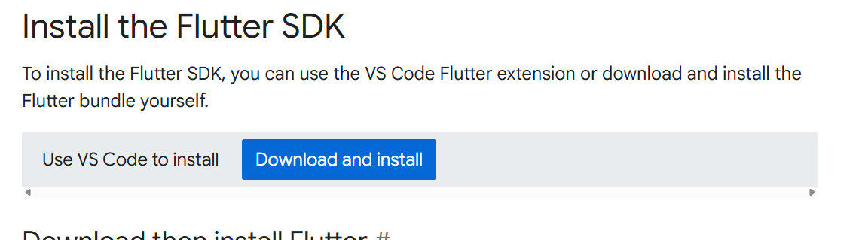
- Download then install Flutter
- Create a folder where you can install Flutter.
For example :
C:\src
- Extract the file into the directory you want to store the Flutter SDK.
For example :
C:\src
- Update your Windows PATH variable

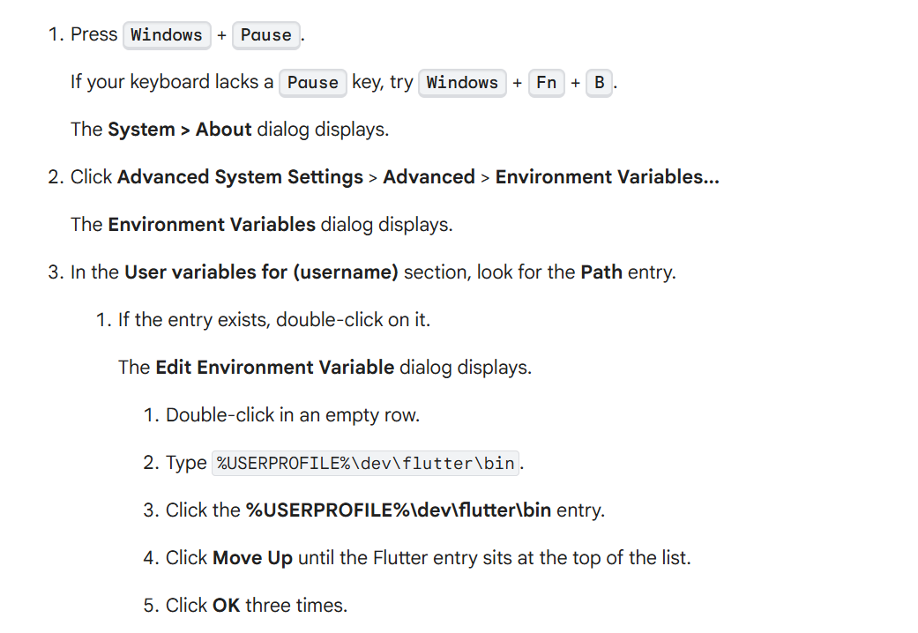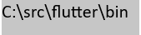
- Open command prompt and type: flutter doctor
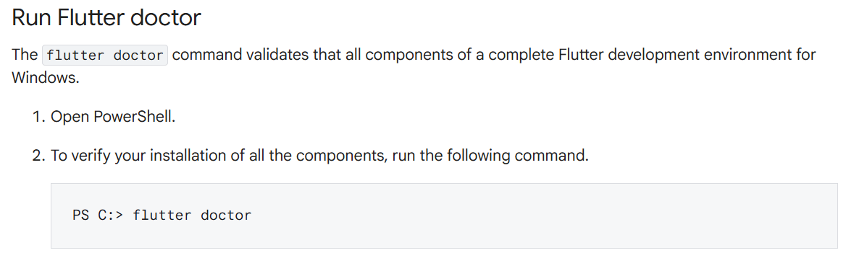
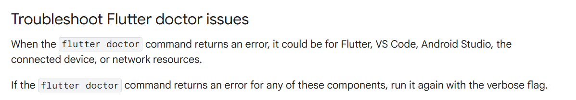
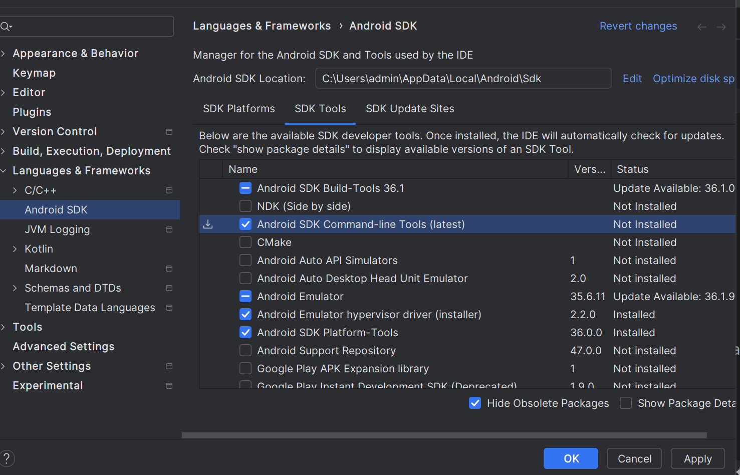
flutter doctor --android-licenses
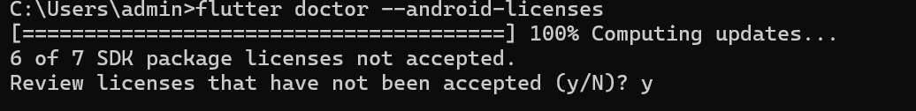
Install flutter plugin
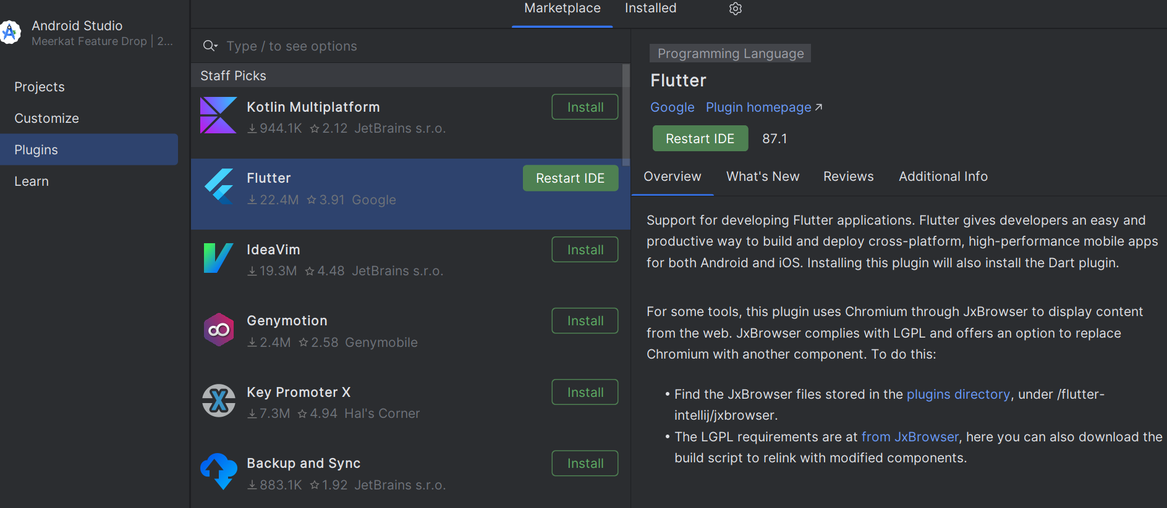
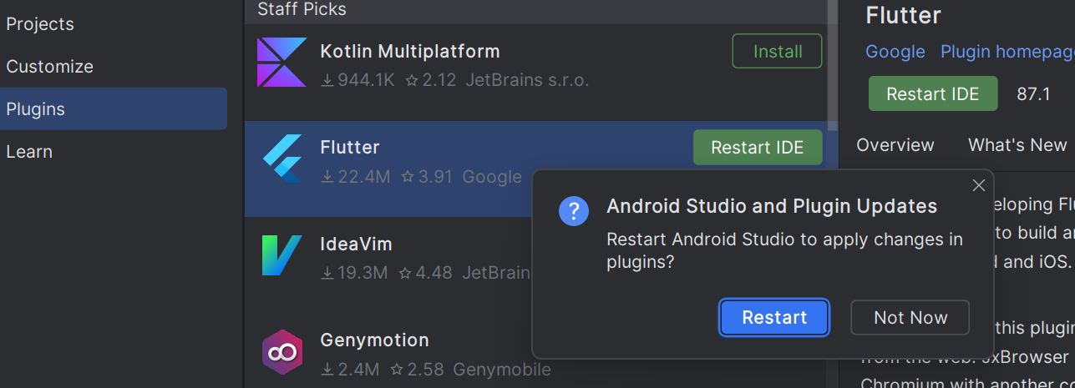
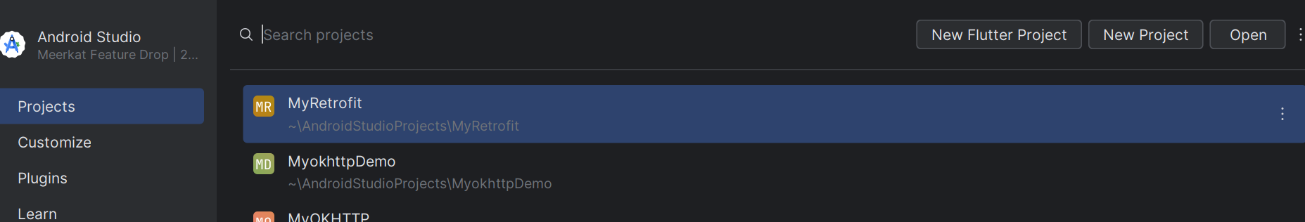

Create flutter project
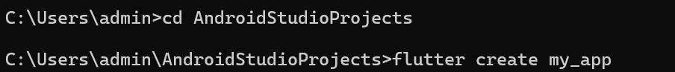

https://www.youtube.com/watch?v=qdaOX1nc3wY
